SSE Covered Play Bid # 21-202
Mandatory pre-Bid and Site Visit –January 7, 2021
A. The Contractor shall provide the following:
1. The size of the building shall be 60 feet long by 80 feet wide and 12 feet in height (clear height under eve).
2. The building shall have a 12 foot clearance at eve.
3. The building shall contain three 20 foot bays.
4. No electrical work is included in the scope of work.
5. The building shall be designed and constructed to meet appropriate sustained wind loads, concrete test and bolt torque standards and shall meet current Florida Building Codes.
7. All framing; eave and rake trim, and downspouts shall be steel, Rain gutters to be .040 aluminum or steel.
8. The standing seam roof panels shall be PBR 24-gauge R-panels or better.
9. The roof pitch shall be designed as gable type system with minimum 2:12 pitch.
On the west and east side of the new building, gutters shall be installed with downspout on north end of gutter, to be connected to drainage system by SCSD.
12. Freight charges must be included in the proposal.

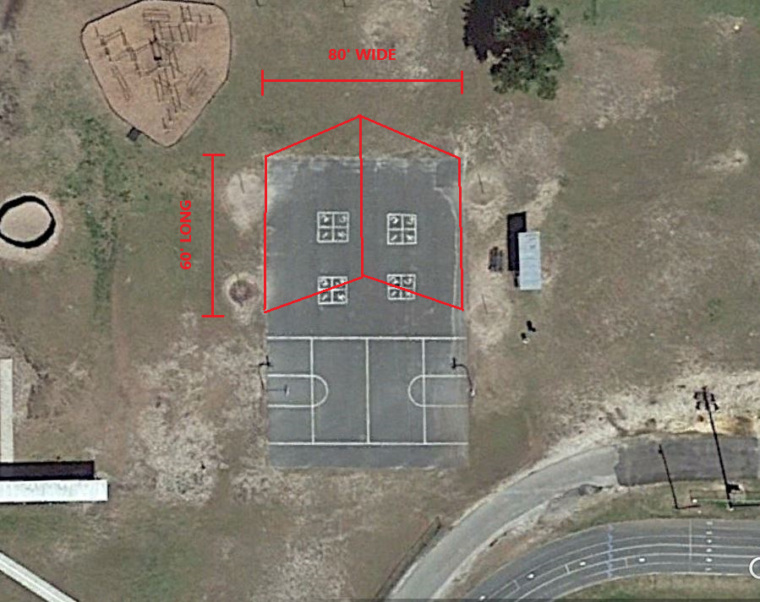

B. Permitting
1. No permitting will be required by the contractor. All permits will be by SCSD through North East Florida Education Consortium (NEFEC)

C. Site Work
1. Existing asphalt is to remain. Any asphalt that needs removal and disposal to pour concrete footers shall be the responsibility of the contractor.

D. INSTALLATION:
1. Installation of building and all associated improvements shall be the responsibility of the Contractor.

G. PROTECTION OF PROPERTY/PROPERTY CONDITIONS:
1. If property is damaged performing work specified or is removed for the convenience of the work, it shall be repaired or replaced at the expense of the bidder in a manner acceptable to SCSD
2. Bidder shall notify the Facilities Director of the work site having pre-existing damage before beginning the work. Failure to do so shall obligate the bidder to make repairs.
3. Bidder shall be responsible for securing all work areas.

J. STORAGE OF MATERIALS:
Contractor shall be responsible for the storage of all materials and/or equipment.

K. DISPOSAL OF WASTE:
The successful Contractor shall be responsible for the daily disposal of all waste materials, debris, and any and all excess materials, containers, etc. at an off-site location in accordance with local, state and federal regulations. The SCSD dumpsters are not to be used by the Contractor.

M. WARRANTY:
The Contractor agrees that the goods furnished under any award resulting from this solicitation shall be covered by the most favorable commercial warranties the Contractor gives any customer for such goods. A copy of this warranty shall be furnished with the bid. At a minimum, all work shall be guaranteed by the Contractor against material defects or workmanship for one (1) year from the date of final acceptance of the entire project by SCSD.

